**Integrate and Fire Network Model**

The network model is comprised of n integrate-and-fire units and up to $n×n$ directed connections between unit pairs. Each unit maintains a potential $Vi\left(t\right)$ which represents the summation of recent synaptic inputs from units with connections to unit $i$. These unit potentials are calculated at discrete time steps where $t$ is a non-negative integer. When the summed synaptic input causes a unit’s potential to exceed a threshold $θ$, the unit “fires” and the spike function $U_{i}\left(t\right)$ is set to 1 for that time step. Each time a unit fires, its potential is reset to zero and an output spike is initiated from that source unit to all of its target units (Fig. 1).

The integrated spiking activity of the modeled units represents the response to the summed post synaptic potentials (PSPs) of a physiological neuron. In order to achieve a PSP shaped effect for each PSP on every arriving spike, a potential $V_{i}\left(t\right)$ is maintained for each unit and is defined as the difference between a slow ${Vs}_{i}\left(t\right)$ and a fast ${Vf}_{i}\left(t\right)$ exponential decay function modeled as simple leaky integrators with multiplication constants $kslow$ and $kfast$ (Fig. 2). If $A_{i}\left(t\right)$ is the sum of all incoming activity to unit $i$ at time *t*, then the unit potential $V_{i}(t)$ is modeled as follows.

$$V_{i}\left(t\right)={Vs}_{i}\left(t\right)- {Vf}_{i}\left(t\right)$$

$$U_{i}\left(t\right)={1, \text{if} V}_{i}\left(t\right)> θ; 0 \text{otherwise}$$

$${Vs}_{i}\left(t+1\right)=kslow×{Vs}_{i}\left(t\right)+A_{i}\left(t\right), \text{if} U_{i}\left(t\right)=0; 0 \text{otherwise}$$

$${Vf}_{i}\left(t+1\right)=kfast×{Vf}_{i}\left(t\right)+A_{i}\left(t\right), \text{if} U_{i}\left(t\right)=0; 0 \text{otherwise}$$

$$1>kslow>kfast$$

Each connection is defined by a weight $W_{ij}$ linking source unit $j$ to target unit $i$. Weights are related to PSP amplitudes by a constant scaling factor derived from the maximum PSP amplitude caused by a spike with a unitary weight. This allows connections to be specified by PSP amplitude rather than the amplitudes of the underlying exponential functions. Non-existent weights assume a value of 0. Axonal and dendritic conduction times are modeled as a global delay parameter $d$ for all connections. To provide additional background activity each unit also receives external input $E_{i}\left(t\right),$ the sum of all external activity arriving to unit $i$ at time $t$. Thus, $A_{i}\left(t\right)$ is defined as follows.

$$A_{i}\left(t\right)=E_{i}\left(t\right)+\sum_{j=1}^{n}{\left(U_{j}\left(t-d\right)∙W_{ij}\right)}$$

Where n = number of input units [?]

The external input to each column is a combination of correlated inputs ${Ec}_{i}\left(t\right)$ and uncorrelated inputs ${Eu}_{i}\left(t\right)$.

$$E_{i}\left(t\right)= {Ec}_{i}\left(t\right)+{Eu}_{i}\left(t\right)$$

Correlated events are selected from an exponential distribution for each column;every unit in the column receives the correlated input at a randomized delay using independent values from a Gaussian function (with a standard deviation of 3 ms). Uncorrelated events are selected from an exponential distribution for each unit individually. By modulating the mean of the exponential distributions at each time step, different forms of background activity can be imposed on groups of units.

**Plasticity Rule**

When the spike-timing plasticity training is active, connection strengths are modified based on firing times of the target and source units. The Spike Timing-Dependent Plasticity Curve (Fig. 3) shows how much weight $W_{ij}$ is changed given the difference in spike times between the target unit $i$ and the source unit $j$. A positive difference (target spike time – source spike arrival time) will strengthen the weight, while a negative difference will weaken it. The same STDP function was used for excitatory and inhibitory connections..The weakening/strengthening value plotted in Fig. 3 was multiplied by a constant training rate factor to control the speed of training. Weakening moves a weight towards zero, while strengthening moves a weight away from zero regardless of whether the weight is inhibitory or excitatory. The weakening side of the STDP Curve is shorter but decays more slowly than the strengthening side, and has larger overall area. This prevents uncorrelated activity from unlimited strengthening of all weights.

Choosing the right amount of weakening vs strengthening is important to the progression of the network connections. The ratio is normalized by setting the Strengthening amplitude to 1, and then choose a Weakening factor to balance the amount of weakening vs strengthening in the network (area of weakening curve vs area of strengthening curve). These values are multiplied by an additional factor called the Training Rate which limits how much a weight can change for any pair of spikes.

If the Weakening factor is too low, then the area of the Strengthening side of the STDP curve will eventually cause all weights to grow to a maximum limit. If the Weakening factor is too high, then all weights will gravitate towards some minimum limit. We picked a Weakening factor such that the network sustained low values on all weights when no additional conditioning is applied, but showed increases in some weights when conditioning is applied.

For a single weight and a spike time difference between single firings of $Unit i$ and $Unit j$ (at PSP arrival), the change in that weight was proportional to the value taken from the STDP function in figure 4. Because it would be inefficient to apply weight changes for every pair of spike times, firing histories were maintained as leaky integrators in the same manner as the unit potentials except with larger constants to provide longer decays (see Table 1 for values used in simulations).

The amount of strengthening depends on the firing history $S_{j}(t)$ of the source unit, and the amount of weakening depends on the firing history $T_{i}(t)$ of the target unit. The constant $ca$ is the learning rate for strengthening effects $(1 * Training Rate)$, $cd$ for weakening $(Weakening Factor * Training Rate)$.

$$S_{j}\left(t\right)={Ss}_{j}\left(t\right)- {Sf}_{j}\left(t\right)$$

$${Ss}_{j}\left(t+1\right)=aslow {Ss}_{j}\left(t\right)+ca U_{j}\left(t-d\right)$$

$${Sf}_{j}\left(t+1\right)=afast {Sf}_{j}\left(t\right)+ca U_{j}\left(t-d\right)$$

$$1 > afast > aslow$$

$$T_{i}\left(t\right)={Ts}_{i}\left(t\right)- {Tf}_{i}\left(t\right)$$

$${Ts}_{i}\left(t+1\right)=dslow {Ts}_{i}\left(t\right)+cd U_{i}\left(t\right)$$

$${Tf}_{i}\left(t+1\right)=dfast {Tf}_{i}\left(t\right)+cd U_{i}\left(t\right)$$

$$1 > dfast > dslow$$

The change to $W_{ij}$ at a given time step is:

$$δ_{ij}\left(t\right)= S_{j}\left(t\right) U_{i}\left(t\right)-T_{i}\left(t\right) U_{j}\left(t-d\right)$$

$$W_{ij} \left(t+1\right)={F(W}_{ij}\left(t\right), δ_{ij}\left(t\right))$$

The weight dependence function $F(W,δ)$ limits excitatory weights to the range $0<W≤wmax$, and inhibitory weights to the range $-wmax≤W<0$.

$$F\left(W,δ\right)=Max(+0,Min\left(wmax, W+δ \right))\text{, if }W≥0$$

$$F\left(W,δ\right)=Min\left(-0,Max\left(-wmax, W+δ \right)\right)\text{, if }W<0$$

**Network Topology**

Units were separated into three groups: Column A, Column B, and Column C as shown in figure 4. Each column has 40 excitatory units [*e*] which only project positive weights, and 40 inhibitory units [*i*] which only project negative weights. Excitatory units can connect to all other excitatory and inhibitory units, but inhibitory units only project to units within the same column. Unit self-connections are not allowed. When connecting a group of units, for example Column A excitatory units to Column B excitatory units $(Ae→Be),$ a probability per possible connection is specified so that only a percentage of possible weights are created. Each column has a simulated local field potential (LFP) which represents the total activity in the column. It is calculated as the sum of all post synaptic potentials arriving within the column.

External excitatory inputs are provided for each column separately. These bias units deliver Poisson distributed spikes with mean firing rates of 900 spikes/sec. Some bias units provide correlated input to multiple [all?] units of the column, and other inputs are independent. The ratio of correlated to uncorrelated units can be modified to control degree of synchronization. The mean bias rate can also be modulated, for example to drive oscillatory activity or simulate behavioral modulation.

**Conditioning Stimulation**

A stimulation to unit $i$ at time $t$ is modeled by adding the conditioning stimulus to the unit’s ${Vs}_{i}\left(t\right)$ value without mirroring it to ${Vf}_{i}\left(t\right)$. This causes a large and immediate deflection towards threshold in the potential of any stimulated unit. Normally a conditioning stimulus is applied to all units in a column at the same time, which will cause many of them to fire. This volley of spikes will cause a measurable response in the LFP of other columns. This evoked response is referred to as the Evoked Potential (EP). The EP is used as a measure of the strength of the synaptic connections from the stimulated site to the recording site. The size of each EP is measured as the difference between the amplitude of the LFP peak after the stimulus compared to pre-stimulation baseline LFP. The average change in the EP amplitude produced by conditioning is quantified as the percent increase of the average EP amplitude after conditioning compared to before conditioning.

$$API =\frac{ 100 (Post Conditioned Average EP –Preconditioned Average EP)}{Preconditioned Average EP}$$

**Implementation**

The network has many parameters which can be modified and can greatly affect the outcome of a simulation. Timing parameters are generally scaled in milliseconds. Connection strengths, stimulation amplitudes, and PSP related parameters are scaled in microvolts to keep such values somewhat relatable to physiology. The networks run in time steps of 0.1 milliseconds to strike a balance between accuracy and computation time. Initial weights are usually small values (20 to 60 percent of maximum) taken randomly from a uniform distribution. Simulated local field potentials (LFP) for each column are calculated as the sum of all PSPs targeting units in the column. These PSP contributions are summed at the same time each PSP is added into its target unit’s potential. The network simulations were run for 2000 seconds of simulated time divided into four stages (Fig. 5). Each stage runs for 500 seconds, the first with plasticity on and conditioning off, the second with both off, the third with plasticity on and conditioning on, and the last with both off. This allows a comparison between running the network with and without conditioning, where the comparison values are calculated during the sections where both conditioning and plasticity are turned off and network connections remain static.

Network Parameters:

|  |  |
| --- | --- |
| Number of excitatory units in each column | 40 |
| Number of inhibitory units in each column | 40 |
| Unit Firing Threshold | 5000 uV |
| Conduction Delay | 3 ms |
| External Input PSP size | 350 uV |
| Kslow  Kfast | 0.96875  0.875 |
| External input Uncorrelated Rate | 900 spikes per second |
| External Input Correlated Rate | 900 spikes per second |
| External Input Correlated Standard Deviation | 3 ms |
| Weakening Factor | 0.55 |
| Training Rate | 100 |
| Aslow  Afast  Dslow  Dfast | 0.9935  0.95  0.997  0.95 |
| Conditioning Stimulus Size | 2000 uV |
| Conditioning Delay | 10 ms |
| Maximum Weight | 500 uV |
| Probability of excitatory connections | 1/6 |
| Probability of inhibitory connections | 1/3 |

**Figure 1**. Unit potential calculation. External input and spiking input from connected units will sum into a target unit’s potential. If a unit’s potential reaches threshold it will be reset to 0 and the unit will send a spike to all of its target units. The spike will cause a Post Synaptic Potential proportional to Wij. This PSP may be excitatory or inhibitory depending on the sign of Wij.

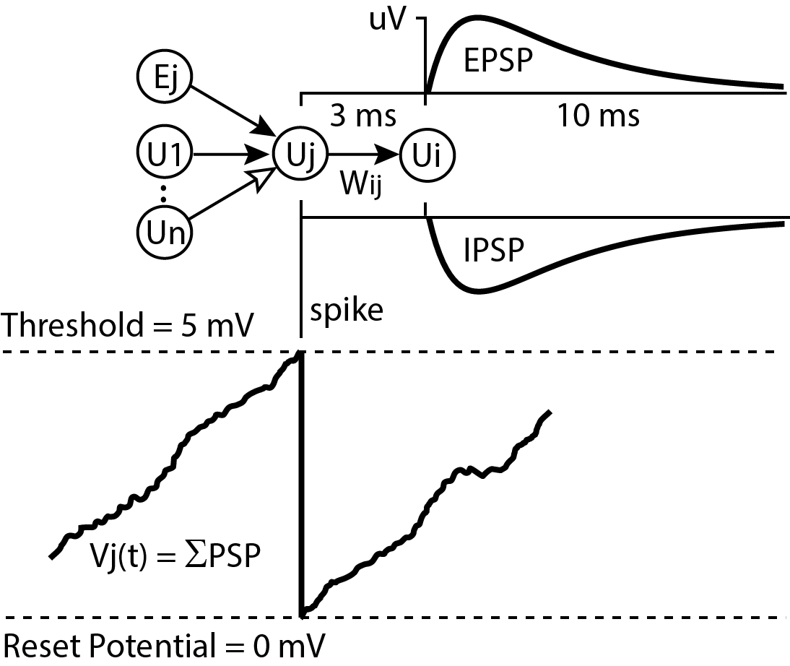

**Figure 2**. PSP Shape. The kfast and kslow constants create a PSP shaped deflection in a unit’s potential for every incoming spike. All networks use kfast = 0.9688, kslow = 0.875 which yields a PSP shape peaking at 1.5ms and running nearly its full course within 20 ms. The PSP amplitude is converted into a Weight by multiplying by scaling factor.



**Figure 3.** The Spike Timing-Dependent Plasticity Curve shows how much weight $W_{ij}$ is changed given the difference in spike times between the target unit $i$ and the source unit $j$. A positive difference (target spike time – source spike arrival time) will strengthen the weight, while a negative difference will weaken it. This weakening/strengthening value is multiplied by a constant training rate factor to change the speed of training. Weakening moves a weight towards zero, while strengthening moves a weight away from zero regardless of whether the weight is inhibitory or excitatory. The weakening side of the STDP Curve is shorter but decays slower than the strengthening side, and has more overall area. This prevents uncorrelated activity from unlimited strengthening of all weights.



Weakening

Strengthening

**Figure 4.** Units are divided into 3 columns A, B, and C. Columns A and B are involved in conditioning experiments while column C is a control to measure how condition affect connected columns that are not directly involved in any conditioning. Each column contains a set of excitatory units and a set of local inhibitory units. Both sets may receive inputs from adjacent columns but only excitatory units project to other columns.

